Mite Drift Quantification:
A Citizen Science Project
Updated January 2026
Randy Oliver
ScientificBeekeeping.com
Hi All, I’ve gotten surprisingly few volunteers to join in this project, so thank you for being willing to collect this important information
Thanks for your participation!
Randy
Note: participation in this project is most appropriate for those with at least a few hives, and preferably for those who have previously counted mites on stickyboards. If you’re interested, please read all below, and then email me your mailing address and the number of hives that you need miticide strips for (please put the words “mite drift” in the subject line of the mail). Be sure to study every one of the 22 pages prior to writing to me with questions! Thanks, Randy
Update: I’ve detailed this protocol more in my series
Can Robber Screens Reduce Mite Immigration? Part 4/ []

There’s been a lot of discussion on “mite bombs” and the drifting of bees and mites from hive to hive. But there’s been surprisingly little research to measure exactly how many mites actually do manage to successfully catch rides into other hives. I’d like to offer an opportunity for beekeepers to answer that question ourselves.

Background
Most of us have observed sudden spikes in the mite levels of our hives late in the season. There have been a few published studies on this, which I summarized in the graph below (Fig. 1).

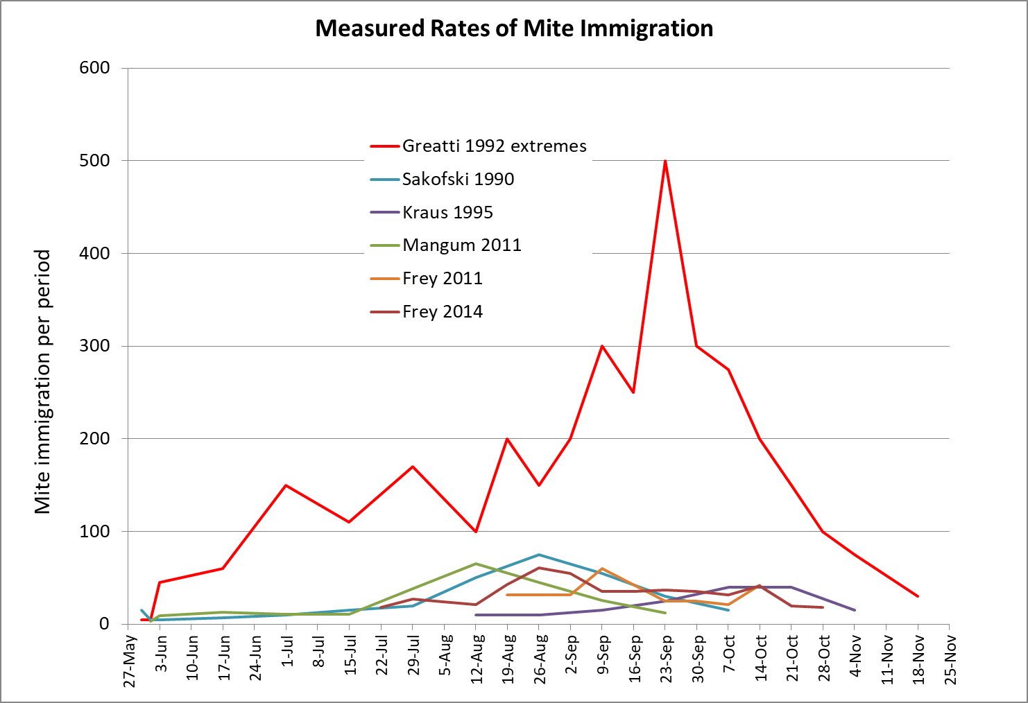
Figure 1. Greatti’s [] figures indicate that it’s possible for thousands of mites to immigrate into a hive late in the season. This mite drift can then prime a treated and otherwise healthy colony for winter collapse.
My own published and yet-to-be published studies confirm the above, although I’ve yet to record immigration as intense as the found by Greatti. The semi-weekly immigration in my 2018 study is shown below (Fig. 2).
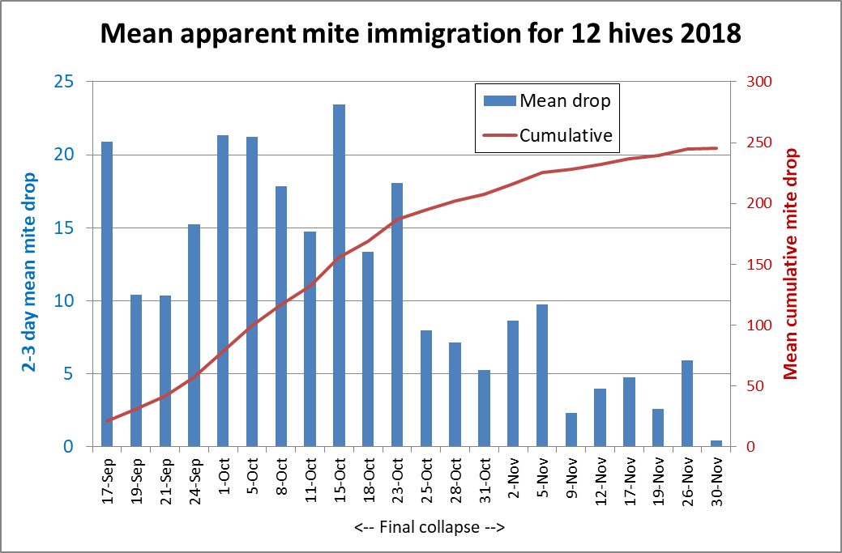

Figure 2. Average mite drops from twelve continually-treated, apparently mite-free colonies in my home yard in 2018, placed at different distances from nine Donor colonies collapsing from varroa. A few weeks prior, I hadn’t detected any mites coming in, so I’d waited until my experiment actually began in mid-September to start inserting stickyboards again. It looks as though I did so a bit late, as mites were already flooding in by then.
Note the big drop in immigration after 23 Oct, although the daily high temperatures continued in the 70s through the middle of November. That 25 Oct decrease coincided with the final collapses of the Donors, which generally occurred between 15 and 30 October.
When I reinserted stickyboards during a rainy period in December (not shown), mite drop in all monitored hives was zero – indicating that no mite reproduction had been taking place in any of the treated monitor hives.
Important point: The above data is for averages of the mite drop counts, but immigration varied greatly from hive to hive -- the cumulative mite immigration counts for the 12 hives varied tenfold. I’ve observed this huge hive-to-hive variation in every study I’ve run. For example:
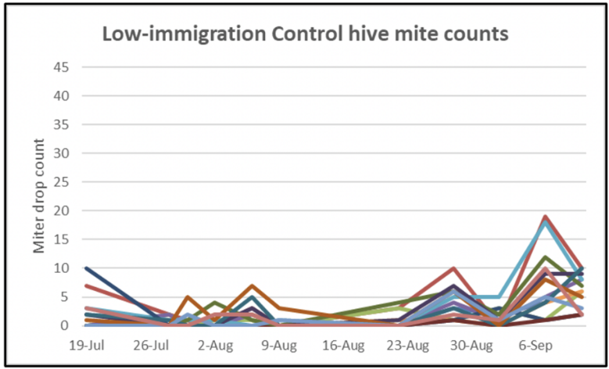
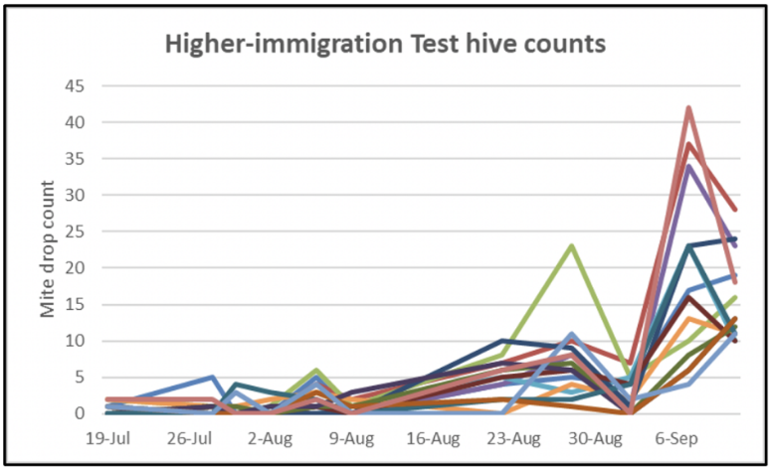
Mite immigration counts from hives in the same yard. Some hives consistently receive more hitchhiking mites.
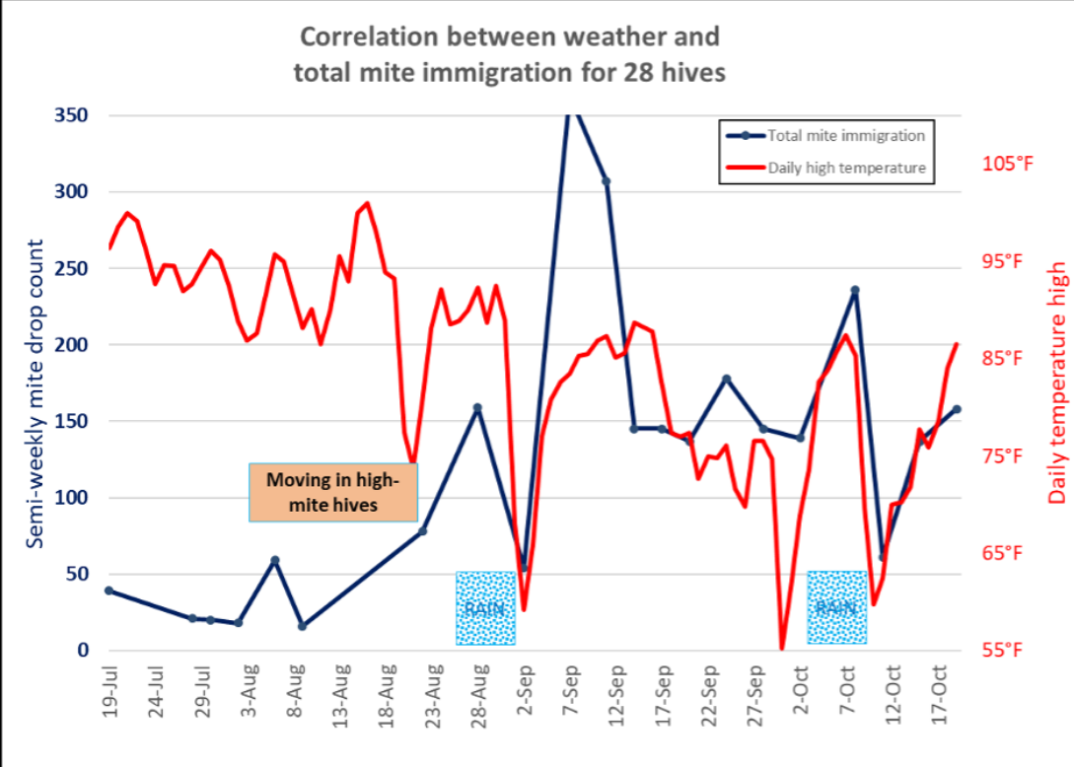
Note the increase in immigration once I moved in collapsing hives adjacent to the receiver hives.

Curious about whether the above data truly represented mite immigration, I repeated the monitoring in six hives in the same yard the next year. By luck, we had a couple of rain events, which prevented bee flight on those days:
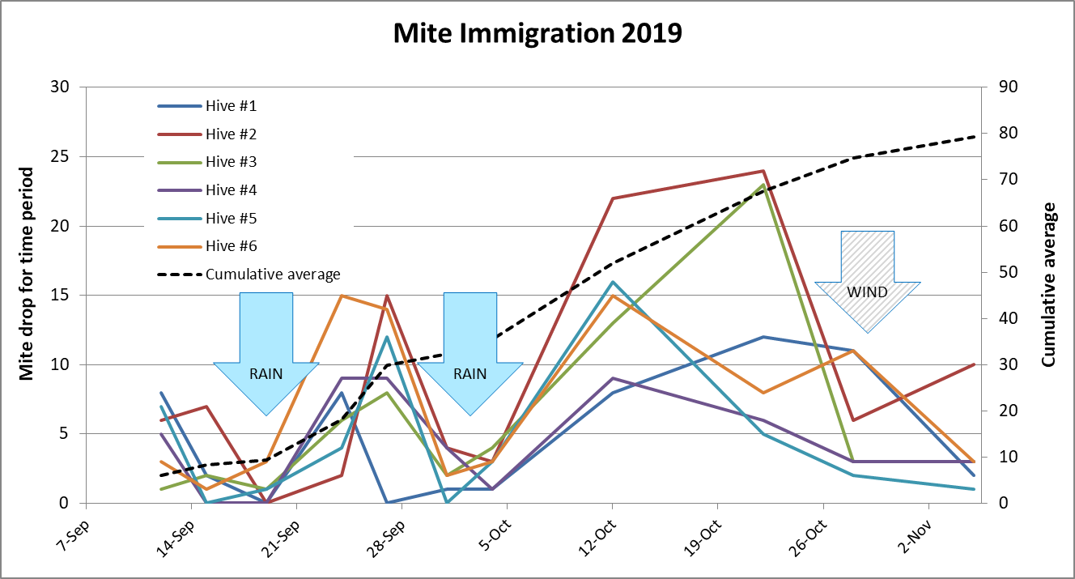
Data from 2019, shown as a line graph. Note how daily mite drops fell off when rain or wind prevented bee drift.
Study recommendation: Use rain events to confirm that you don’t have mite reproduction taking place in your monitored hives.
Practical application: it’s clear that mite immigration in late summer and fall can be substantial. A flood of incoming, reproductively-active mites coming into a hive, just as it’s downsizing for winter, could cause real problems.
Practical application: some hives in the same yard pick up far more mites than others. Why this is I don’t know, but it has huge implications for mite management, and possible directions for selective breeding programs.
We clearly need more data of this sort from across the country! If you’re interested in helping, here’s the protocol:

The Protocol
Basic outline:
- Eliminate 100% of the mites from a hive, including the broo, by use of multiple slow-release varroacides , and perhaps brood removal.
- Confirm that the colony is mite-free by both mite wash and stickyboard. Mite fall on a stickyboard will drop to zero if there is no bee flight (such as on rainy days).
- Continue the miticide treatments while you monitor mite drop onto a stickyboard. Any mites that manage to hitch a ride into the colony will be killed by the extended-release miticides before they and enter the brood. So any mite fall from this point on will be of mites that must have come in from elsewhere.

materials and amount of work involved
You’ll need to follow the protocol below exactly, so that we can compile and compare the data. Your monitor hives will need to have varroa completely eliminated well in advance, so best to start by mid-May -- you can’t procrastinate.
Once you get the mites down to zero, each monitor hive (more than one would be best) will need a screened bottom and two stickyboards to swap out. You’ll need to perform stickyboard counts twice a week, or arrange for someone to cover for you. Luckily, you won’t likely need to count too many mites each time—most counts will be of less than a dozen mites.

the protocol
- Decide how many hives you want to include in this project. Each hive will require the counting of a stickyboard twice a week. This takes me, with reading glasses or a magnifier headband, well less than 5 minutes per count and reinsertion of the stickyboard.
- Optional: If you’re in an area in which colonies do not normally gain weight due to lack of nectar flows late in the season, you can collect additional valuable data by placing the hive(s) on electronic scales. This information will indicate whether the hive was engaged in robbing behavior at any point of time (and thus correlate with an increase in mite immigration). Any accurate electronic scale will do. Broodminder sells an inexpensive scale, and the owner, Rich Morris, will walk you through the setup if you mention that you are engaged in this project with me Rich@broodminder.com. If you do use a scale, be sure to verify that it is indeed collecting data, and print out the weight graph on a weekly basis.
- At least six weeks in advance (I suggest by April) choose one, or preferentially more, healthy hives to monitor. They do not yet need to be strong, provided that they have young queens, and are expected to grow to full strength by mid-August. Starting with a nuc or package is great, since it is easier to completely eliminate the mites from a smaller colony. In order to avoid inadvertently selecting colonies that may exhibit some sort of resistance to invasion, it may be best to start with colonies that exhibit “normal” mite counts. Best to start the winter before, with an oxalic dribble to the hive. Then start treatment again as soon as the colony begins broodrearing, in order to prevent mites to start reproducing in the brood.
- Eliminate the mites:
  - First remove any honey that you want to harvest, since you will be applying miticides throughout the project.
  - It the initial mite infestation rate is above 2 mites/100 bees, it will be of help to either remove or scratch open any sealed brood, and apply a 1:10:10 (OA:sugar:water) oxalic acid dribble. Or temporarily remove the queen and frame of sealed brood and nurses to to a nuc for safekeeping, and apply a strong formic treatment to the colony. You can replace the queen after the formic fumes dissipate (don’t replace the workers or brood).
  - Then simultaneously apply two different time-release synthetic miticides (e.g., Apistan®, Checkmite II®, or Apivar®) at the full label rate for the size of the colony (Fig. 3). (The label rate is typically 1 strip per every 5 frames covered by the cluster of bees. I had very good results by applying both Apistan and Apivar strips at the rate of one strip of each type for every five frames of bees [].
Where allowed, an additional extended-release oxalic pad can be added.
If you don’t want to purchase full packages of the strips, I’ll be happy to provide the total number of strips needed, free of charge. Please email me your address, and the number of hives you need strips for. I will send 3 strips of each product per hive. If the hive is still growing, insert 1 strip of each product per 5 frames covered with bees to start with, and add additional strips as the colony grows. Allow the strips to remain in the hive until the end of mite counting. The strips must be distributed throughout the cluster, in contact with the bees, since the miticides are distributed by contact with moving bees.

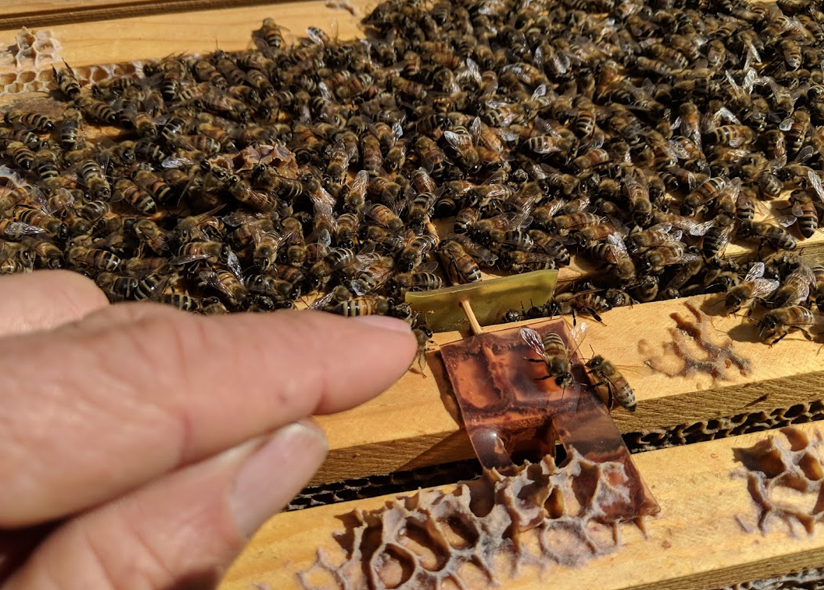
Figure 3. Use one strip each of Apivar and Apistan for every 5 frames of bees in the cluster. Since you’ll be leaving the strips in the hive for the duration of the experiment, you cannot harvest any honey for human consumption from these hives – instead use it for winter feed. Monitor the mite drop with stickyboards (Figs. 4-6) until it drops to zero per day (and you feel confident that there are no mites left in the hive). This should occur by the first of July.
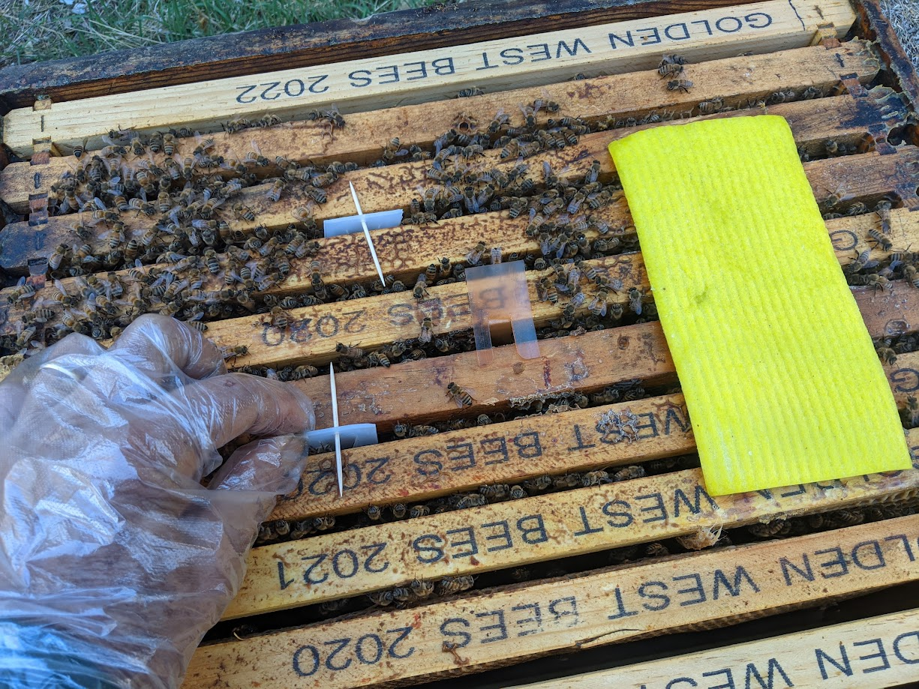
It may take some work to eliminate all the mites, so begin preparing colonies at least two months in advance! Give them a strong formic or extended-release thymol treatment. Then follow up with a combination of synthetics (here Apistan and Apivar), plus an extended-release OA pad.
- By early July, install bottom boards adapted for stickyboards. These are readily available commercially, or you can build your own (details below). At this point of time, semi-weekly mite drops should be zero.
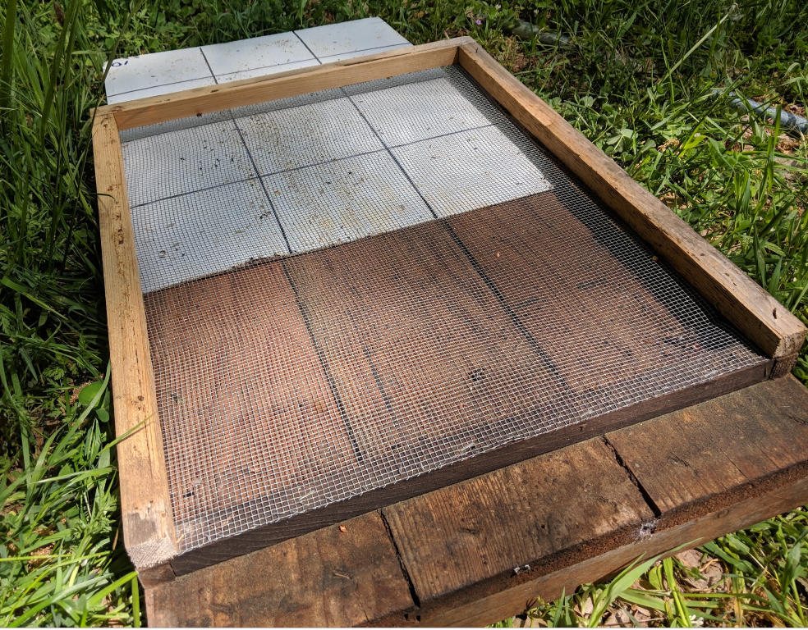
Our bottom boards already have ¾” cleats, so I simply move the rear cleat to the front of the bottom board, and build a three-sided frame with 1/8” hardware cloth stapled onto it. I flip the screened frame over and tack it on top of the existing cleats. This leaves a screened bottom board with an entrance to the rear (the bees climb up the front cleat to enter). The stickyboard slides in from the rear. If there is any sag in the hardware cloth, it may scrape the top of the stickyboard. Use a hooked wire to bend it up, or increase the spacing above the stickyboard.
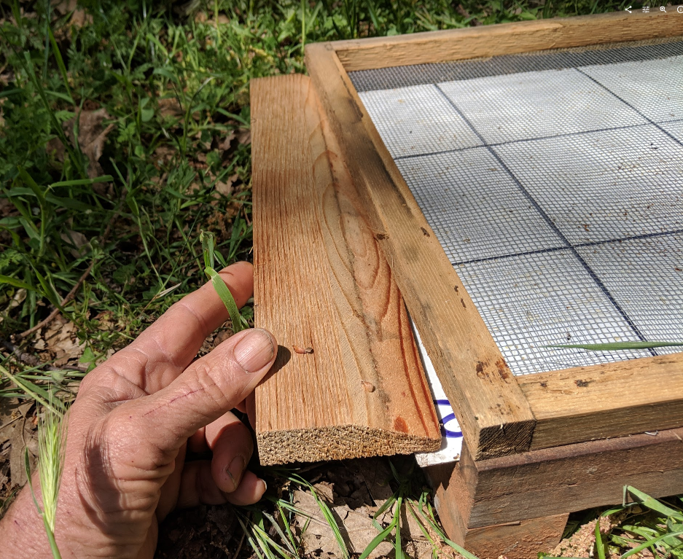
At the rear of the bottom board I insert a tapered block to prevent any bees from entering the stickyboard space.
- Starting in late July or August, keep a stickyboard in the hive continuously, taking regular mite counts twice a week (to avoid accumulation of hive trash on the stickyboards). It’s easiest to simply assign two days each week for monitoring—e.g. Saturdays and Tuesdays. I have found that it’s OK to feed an attractive pollen sub if necessary for colony health, since virtually none falls onto the bottom board. Since there are no mites left in the hive by this time, any mites found on the stickyboards must have been carried in from outside, and then quickly killed by the miticides. Record this data by date and mite count (sample data sheet attached). Continue these counts until colonies go dormant from the cold (winter data would be of interest from where bees fly all year). If you need to go on break, no worry—just continue with mite counts when you return, leaving a gap in the data.
- If you’re over 25 years of age, for counting the mites, be sure to use magnification for accurate counting of the mites. You can wear reading glasses, or a flip-up jeweler’s magnifying headband as shown below—available at https://www.magnifier.com/headband-magnifiers.htm
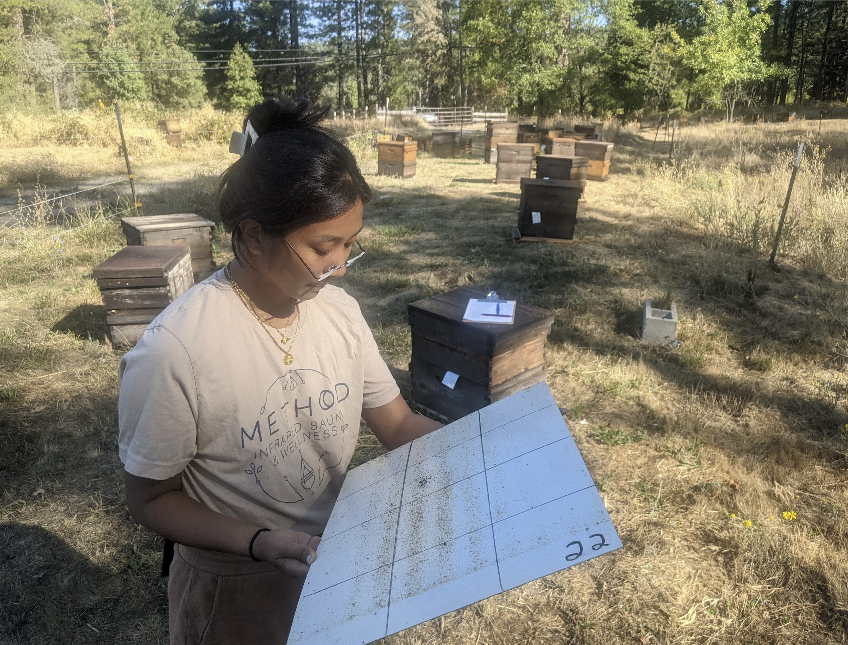
Rose Pasetes counting a stickyboard. Even she found that a pair of weak reading glasses helps.
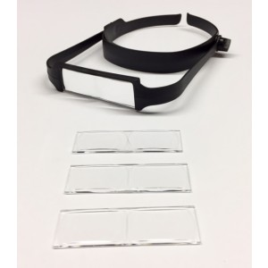

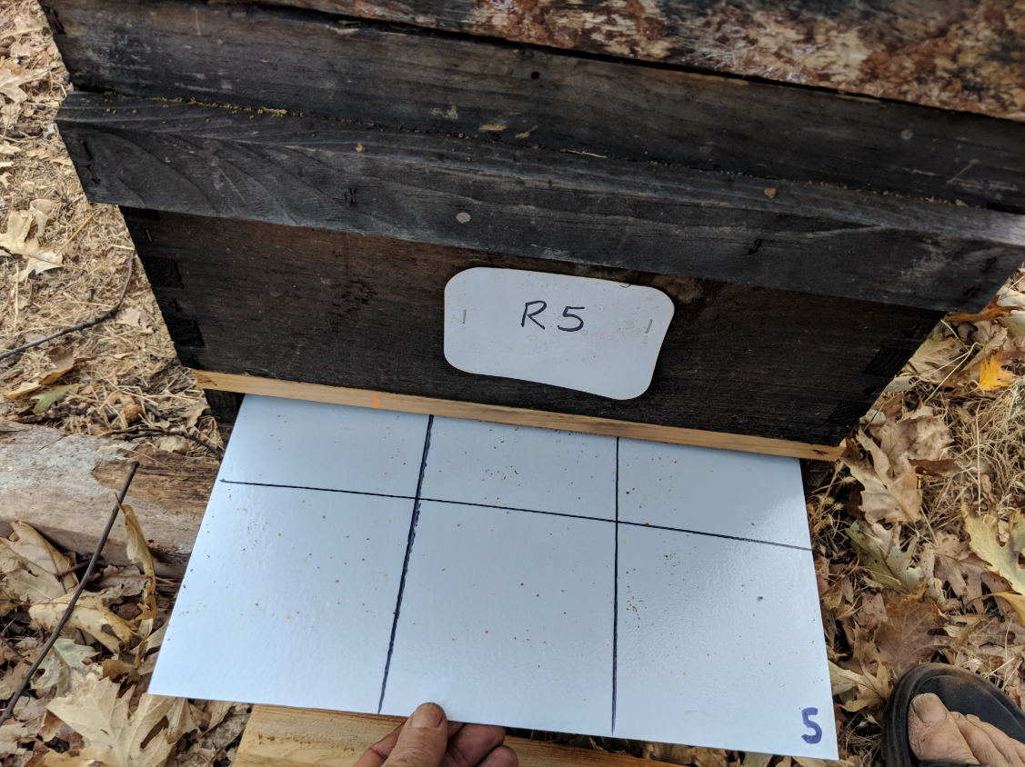
Figure 4. Each monitor hive must be set up with a screened bottom of 1/8” hardware cloth, over a holder for a stickyboard. Be sure that the screen does not sag anywhere near the stickyboard, nor insert a warped stickyboard, or the mites may be scraped off when you withdraw the stickyboard for counting. On this stickyboard I’ve drawn a grid in order to make accurate mite counting easier (Marks-A-Lot brand felt pen ink is stable in the Vaseline), and labeled the stickyboard with the hive number. I prefer accessing the stickyboard from the rear of the hive. We simply count the mites right there at the hive (there shouldn’t be too many), record the count, and then scrape the board clean with a sheetrock knive, then lightly re-oil the stickyboard with a roller.

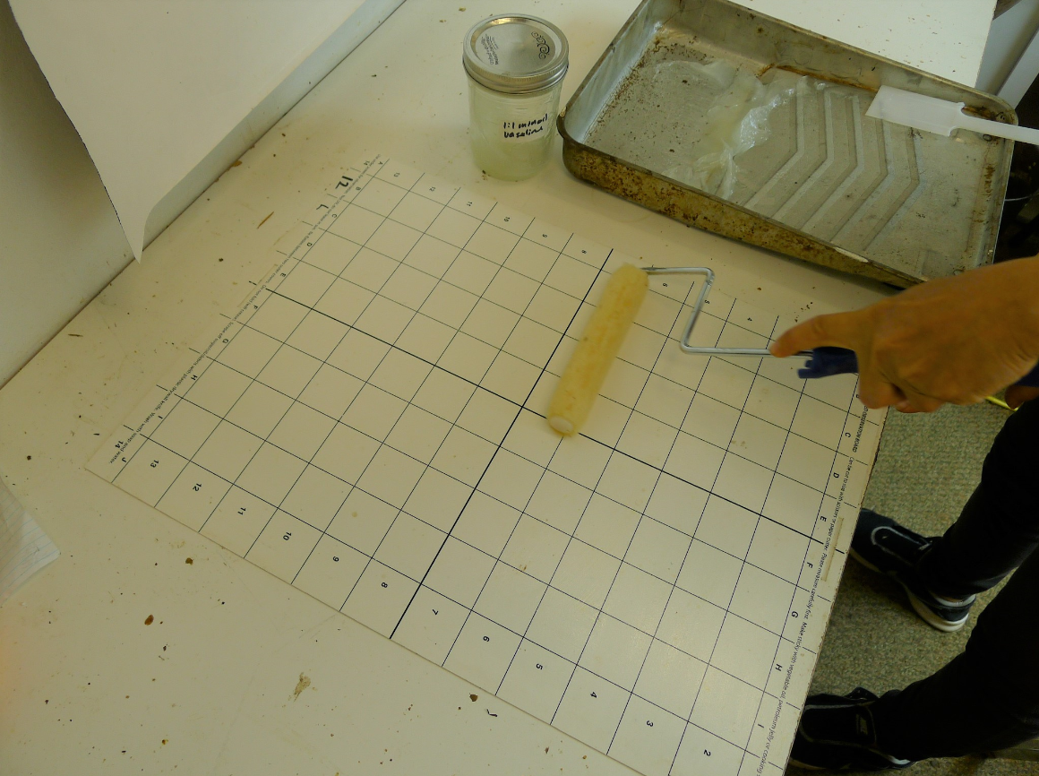
Figure 5. I’ve tried a number of types of stickyboards. The best I’ve found are those I made myself by using a table saw to cut a sheet of white “FRP wallboard” into appropriately-sized pieces []. Draw a grid onto the stickyboard with a black Marks-a-Lot brand felt pen prior to oiling the sheet – the Marks-a-Lot ink will hold up well afterwards. We then use a mini paint roller to apply a mixture of mineral oil and petroleum jelly [] – which prevents any live mites from crawling away, or ants from carrying them off. Tip: use a very thin film of jelly from a fairly “dry” roller, since too thick a layer makes the mites more difficult to count.
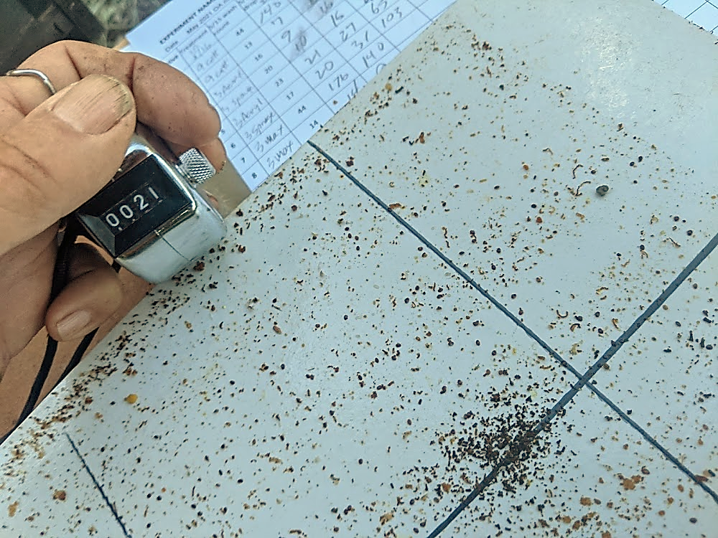
A hand counter allows for much faster and more accurate counting, since you don’t need to concentrate on adding and memorizing.

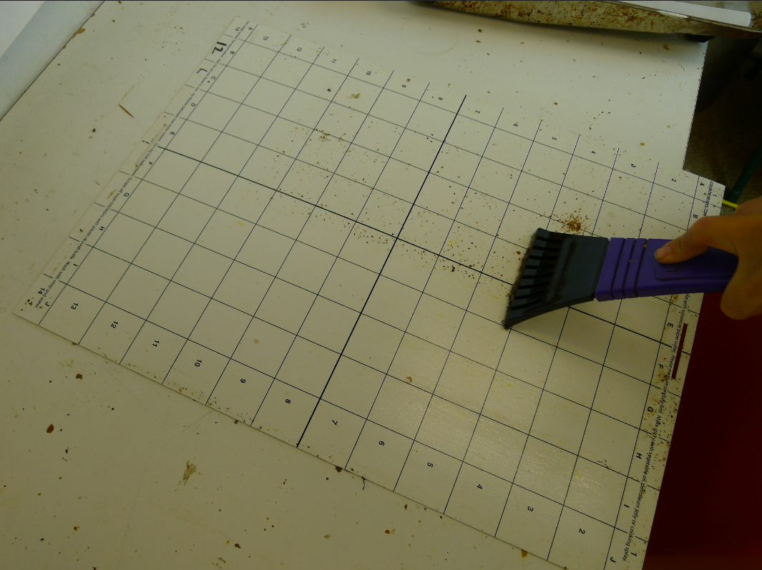
Figure 6. In this photo I show a non-FRP stickyboard with a tighter grid, which I use for experiments in which I expect to have to count larger numbers of mites. Plastic stickyboards can be easily scraped clean with a windshield scraper or (even better) an 8” drywall knife, then rerolled lightly with the petroleum jelly mixture.
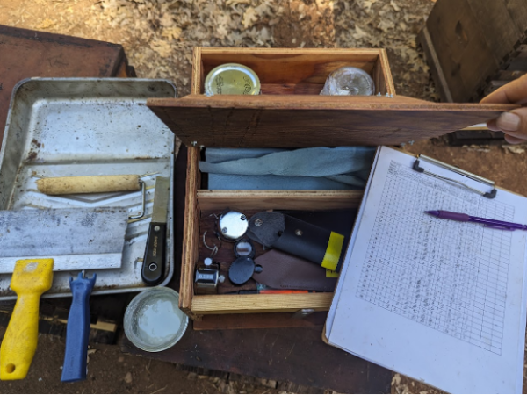
I built a handy kit with a hinged cover to carry all the essentials, including reading glasses, the data clipboard, the paint tray and rollers, and additional sticky jelly.

- Validation of the method: confirm during the monitoring counting period that the treatment strips are indeed continuing to prevent varroa from reproducing in the monitor hives by checking by one or more of the four following methods:
  - Check the drop rate on rainy days when there is no bee flight (it should be zero by the second day of rain).
  - During the monitoring period, alcohol washes should be zero (there may occasionally be one newly-immigrated mite that hasn’t yet been killed.
  - Use a dissecting ‘scope or penlight and magnifying glass to confirm that no mites are in the brood (Fig. 7).
  - The easiest confirmation is that mite counts will drop back to zero once mite drift ceases and cold weather prevents bee flight. Refer back to Figure 2 – if mites had been reproducing in the colony, the drop counts would have gone up as the colony cut back on broodrearing in November.
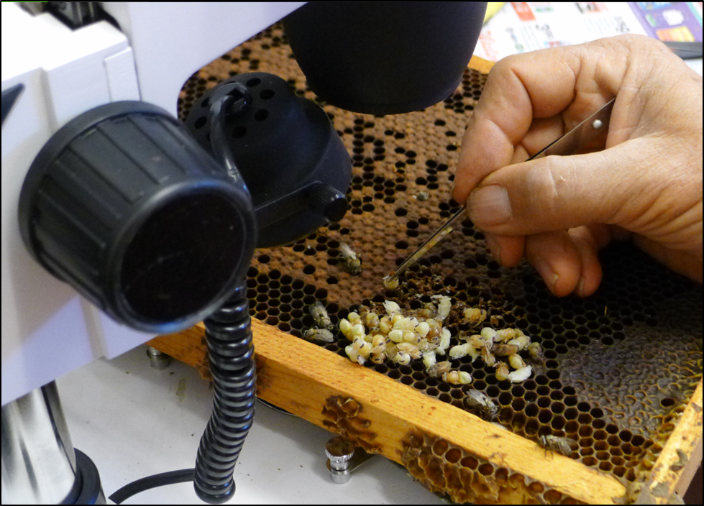
Figure 7. Here I’m using a dissecting ‘scope to confirm that there are no mites reproducing in the brood of a monitor hive, by using forceps to pull out 100 dark-eyed pupae, and then peering into the cell to see whether there are any signs of a mite. This last method is a bit tedious, and generally not necessary.
End of protocol. Any questions, please email me with “Mite Drift Project” in the subject line, or phone me at 530 277 4450. If you need miticide strips, please email me with your mailing address and number of strips needed (typically 3-4 strips of each product per hive).
Apologies in advance: I deal with a large number of emails every day. For this project, ideally I will only need to send these instructions to each collaborator, perhaps package and mail treatment strips, and then receive data sheets to compile. Thanks for understanding the limits of my time!

Data Sheets
The data from your hives will be easiest for me to process if you can send it to me at the end of the trial in Excel or other spreadsheet format. This will allow me to import your data, rather than having to hand-enter each value. Thanks!

Name and Location
Your name and email.
Your location (State, Province, GPS coordinates if you have them)
Please describe your location -- the landscape vegetation (urban, rural, farmland).
The total numbers of hives in your apiary.
Did any hives in your apiary collapse from varroa, and if so, at around what date?
Your best estimate of the total number of hives within a mile radius.
Do you suspect that there were many "managed" hives within a mile that collapsed from varroa?
If so, do you know the date range of their collapses?
Do you suspect that there are many feral colonies or escaped swarm colonies in the vicinity?

Do you also have weight data, and did it indicate a correlation between weight gain and mite immigration?

Other notes of importance?

Mite count data (Raw data entry)

Mite Counts by Date
Please print this data sheet out for field entry of your mite counts. I prefer to print my data sheets on cardstock paper, so that they don’t get damaged. Please also enter the raw data on a weekly basis into a spreadsheet (such as Excel), so that no data gets lost!
Note: it is difficult to count mites on a stickyboard if hive trash is allowed to build up for more than a few days. Therefore, I suggest that you take mite counts at least twice a week. This data sheet is to record that raw data, at the time and place of counting. On the next page is a data sheet into which you can combine your mite counts into totals for each week.
If you also take weight data, you will need to expand this data sheet.
Upon completion of data collection, please either email me the data in a spreadsheet, Word doc, or other form. Thanks!

Please enter semi-weekly mite counts.
See note on following page if you are also collecting hive weight data.
Date | Hive # | Hive # | Hive #

Mite immigration data (summed weekly counts to send to Randy)
Please copy the data sheet below into a spreadsheet that you can send to me.
The dates are arbitrarily set to Saturdays, so that we can easily compare data, since it’s really a mess to graph out the data if we all use different dates. So please simply total your mite counts for the seven day period that overlaps the indicated Saturday date. If you did not collect data for a particular time period, please enter “ND” for “No Data.”
Total Counts for the Week
Date | Hive # | Hive # | Hive #
4-Aug
11-Aug
18-Aug
25-Aug
1-Sep
8-Sep
15-Sep
22-Sep
29-Sep
6-Oct
13-Oct
20-Oct
27-Oct
3-Nov
10-Nov
17-Nov
24-Nov

Optional hive weight data (to monitor robbing)
If your hive is on a scale, please check the weekly graphs of hive weight, so that we can look for a weight spike due to robbing. I will leave it up to you to determine whether any weight gain spikes correlate with a similar spike in mite immigration. If so, then please expand the data sheet to enter hive weight for each time point, so that we can graph the correlation.

Varroa Immigration Project
Application Instructions for the Miticide Strips
We are using two miticides with different modes of action to ensure complete elimination of varroa from the monitored hives, as well as to effect rapid kill of any incoming mites before they can reproduce. This is combined dose and longer application period is more than normally used.
Installation
Insert the strips hanging between two combs, scattering them throughout the cluster—making sure that every strip is well within the cluster of bees, and that strips are hung in both the upper and lower brood chamber. Distribution of the miticides is dependent upon the bees rubbing against the strips. The white strips are Apivar, the brown strips Apistan. It’s OK to place one strip of each side by side, and best to place the strips in and around the brood frames. The label rate for each of the miticides is to apply 1 strip for every 5 frames covered with bees. I’m assuming that your colonies will contain about 15 frames covered with bees, so am supplying 3 strips of each miticide, which should be plenty—even if your colonies are stronger—since we are applying a combined dose of two different miticides. The strips are time-release, and take 6-8 weeks to obtain full efficacy, although since we are applying two different active ingredients, full efficacy may be realized earlier.
The individual strips need to be peeled apart, and the tabs for the brown strips opened to suspend them in the gap between the frames. For the white Apivar strips I personally prefer to shove a toothpick (enclosed) through the hole in the strip, rather than use the tabs.
I do not know of any experimental data for this sort of double application, but from my experience last season, the combination of 2 strips of each applied in early June to 10-frame colonies continued to provide adequate and near immediate mite kill clear through fall. The strips will leave some residues in the beeswax combs, similar to what are found in commercial beeswax.
Some of you are starting with nucs; some with established strong colonies, so you will need to make some decisions on your own as far as treatment. In general, immediately apply 1 strip of each miticide for every 5 frames covered with bees. If the colony grows, add an additional strip of each for each additional 5 frames of bees. If you have any doubts as to whether you’ve applied enough strips, feel free to apply another strip of each in mid August. Do not remove any strips until the end of data collection—your treated colonies will go into winter free of mites!
Safety
Both products are considered safe to handle with gloves and are free of vapors. Follow the attached label instructions, wear latex or nitrile gloves (enclosed), and for disposal of the used strips, wrap them in paper and send them to a landfill. Copies of the product labels are attached. Due to potential contamination, do not harvest any honey from the treated hives for human consumption (any residues in the honey are of minor concern to EPA).
Thank you for participating in this project!
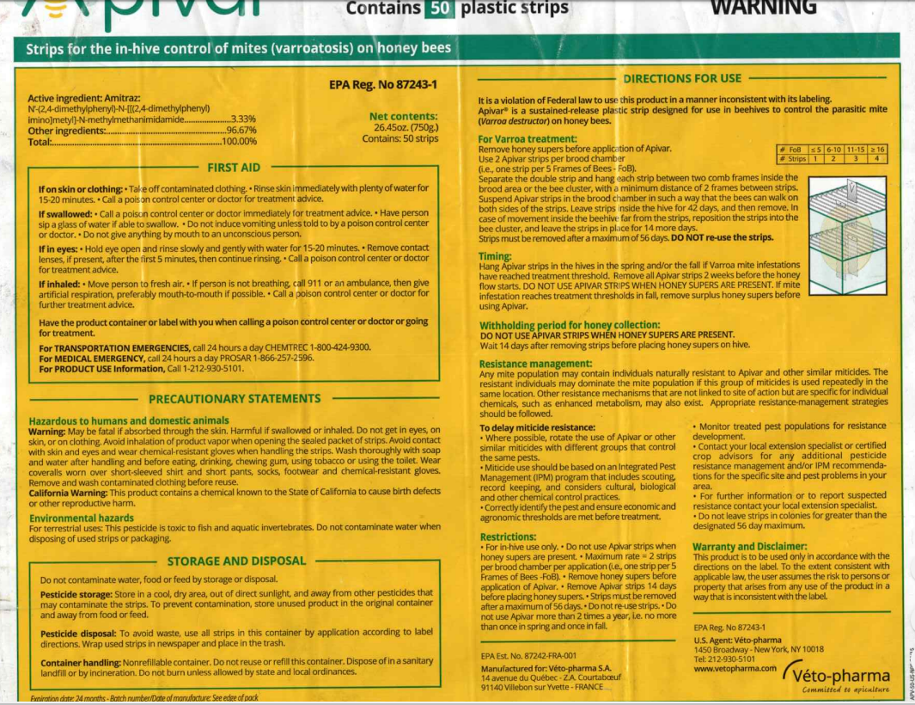
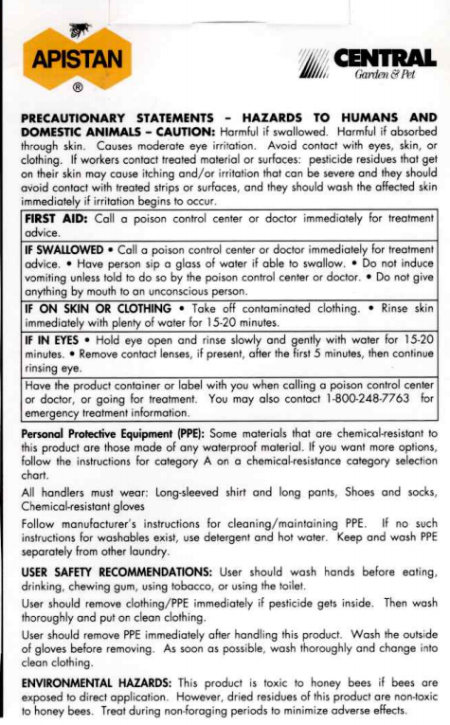
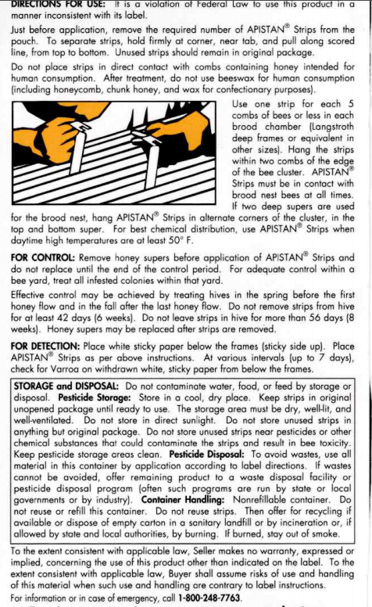
References

https://scientificbeekeeping.com/can-robber-screens-reduce-mite-immigration-part-4/
Greatti,M, et al (1992) Reinfestation of an acaricide-treated apiary by Varroa jacobsoni Oud. Experimental & Applied Acarology 16: 279-286. The sources of the other data are in The Varroa Problem part 16b.
The mites in my operation had no history of exposure to either of those miticides, so I expected high efficacy. No retreatment was required—I just left the strips in ‘til the end of the monitoring. You must confirm via alcohol wash or brood dissection that no mites are reproducing in your monitor hives.
FRP wallboard are 4-ft x 8-ft “fiberglass-reinforced plastic” sheets, readily available at home building supply stores, and used for waterproof wall paneling. The sheets are very strong, don’t warp, and can be reused over and over. I cut them on a tabIe saw, then draw a grid on them before the first application of the petroleum jelly mixture with a black Marks-a-Lot® brand felt pen, which I find holds up very well. The stickyboard in this photo, however, was not made of FRP.
What works well for us is to scoop a 13-oz container of petroleum jelly (Vaseline®) into a saucepan, add a 1-pint bottle of mineral oil, and stir it over gentle heat until the jelly is dissolved. Then pour the mixture into wide-mouth shallow jars to cool.

